Communications Management Plan
The Fighting Moongoses
10/4/2012

Table of Contents
Introduction 3
Communications Management Approach 3
Roles 3
Project Team Directory 4
Communications Matrix 5
Guidelines for Meetings 6
Reference 6

Introduction

This document carries communication management plan for the underlying project Petrol station locator. The main objective of communication plan is to define the communication responsibilities for actor, group or individuals working on the project. The plan also covers source, destination, and medium of the information. As well as the plan also includes the communication directory covering all the major groups or individuals on the project.

Communications Management Approach

There are two communication environments i.e. External and Internal in the underlying project. In the internal environment the project manager is the hub of all communications. Whereas in the external environment it includes sponsors and clients with only the project manager responds to them.

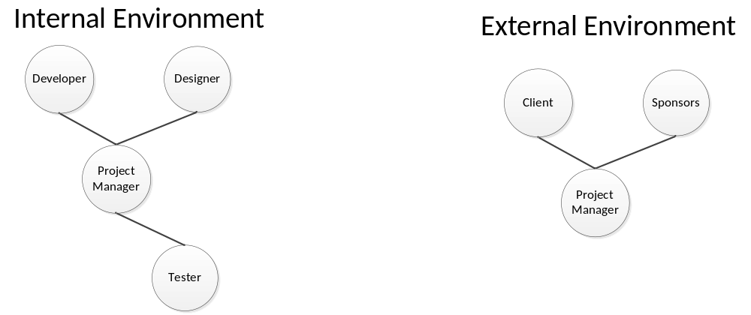

As well as more details are in the communication matrix with tasks required to be performed on periodic basics such as weekly meetings, status reporting, expectation reporting, milestone reporting.

Roles

Project Sponsor
The project sponsor role is to make sure funds are allocated and flowing for the project needs. He has to do communication over this with the clients as well as project manager.

Client
The client role is to facilitate the project manager with the needs and requirements. And if there is any change they want to request that should be communicated with the project manager and sponsors as well.

Change Control Board
The change control board gets request from project manager which is requested by client. The change control board must analyse the change and communicate with the project manager over its feasibility.

Project Manager
The main actor is the project having a role to handle the communication with the external and internal environment. He has a role to communicate with project sponsors and clients over the project funds and project requirements. As well he has to communicate with them the status of the projects and deliverables. Also the project manager is responsible to communicate with the team of developers, team leads, testers and graphics designers over the development of the project.

Project Team Directory
The following table presents contact information for all persons identified in this communications management plan. The email addresses and phone numbers in this table will be used to communicate with these people.

Role | Name | Email | Phone
Project Sponsor | Scott Ashwin
Client | Scott Ashwin
Project Manager | Irfan Arif
Project Team
 | Liam Davis
 | Peter Monus
 | Riemke Aggio
Team Lead | Peter Monus

Communications Matrix
The following table identifies the communications requirements for this project.

Communication Type | Objective of Communication | Medium | Frequency | Audience | Owner | Deliverable
Kick off | Introduce the project and project team individuals, Creation of Project Plan | - Face to Face | Once | - Project Team | Project Manager | - Agenda  - Meeting Minutes
Project Quality Analysis | To discuss the quality of deliverables | - Face to Face | Once | - Project Team | Project Manager | - Agenda  - Meeting Minutes
Project Source Hosting | To discuss the use of GitHub and Google Docs for the work collaboration | - Face to Face | Once | - Project Team | Project Manager
Story Board Discussion Meetings | To discuss design of the project | - Face to Face | Once | - Project Team | Project Manager | - Story Boards
Technical Design Meetings | Discuss and develop technical design solutions for the project. | - Face to Face | As Needed | - Project Team | Project Manager | - Meeting Minutes
Project Team Meetings | Review status of the project with the team. | - Face to Face  - Email  - Call | Weekly | - Project Team | Project Manager | - Status Reports

Guidelines for Meetings

Meeting Agenda
Meeting agenda will be sent to the team members in advance so that everyone gets prepared for the meeting.
Meeting Minutes
During the meetings minutes will be taken and will be emailed to team after completion.
Action Items
Items identified as ‘to do’ will be specifically listed along with the team members(s) responsible for the work on that action item.
Owner
Owner of the meeting must ensure the agenda of the meeting has met and deliverable associated with the meeting is completed. He/she also needs to engage all the participants in a communication oriented environment.

Sponsor Acceptance

Approved by the Project Sponsor:

Date:
<Project Sponsor>
<Project Sponsor Title>

Reference
Project Management Docs
www.ProjectManagmentDocs.com [viewed on 02 September, 2012]

